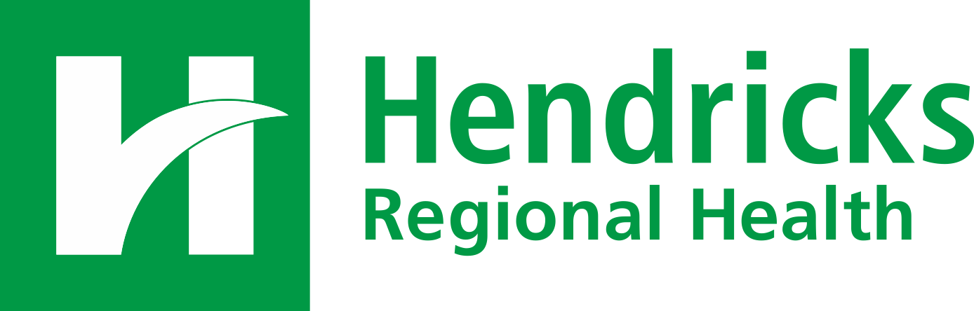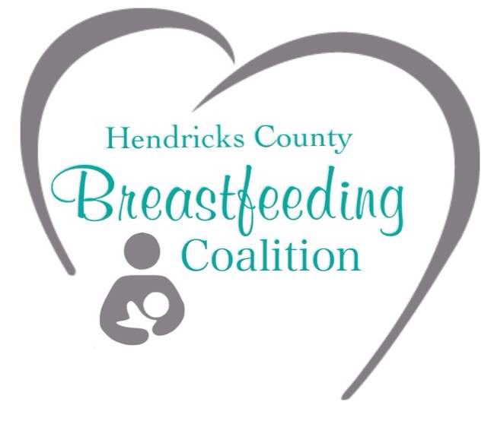

For Immediate Release Contact: Stacey Bulla

October 17, 2016 skbulla@hendricks.org

(317) 745-8407

# Hendricks Regional Health and The Milk Bank Open New Milk Depot

Danville – Hendricks Regional Health is taking action to further support mothers in meeting their breastfeeding goals by partnering with The Milk Bank to open Hendricks County’s first milk depot site.

According to the Hendricks County Breastfeeding Coalition, the benefits of breastfeeding extend well beyond basic nutrition. These donations to The Milk Bank will go a long way toward keeping our community’s children healthy.

Hendricks Regional Health nurse and certified lactation consultant Deb Beck initiated the effort to bring the depot to Hendricks County. The new milk collection site at the Hendricks Regional Health Pediatric Unit provides a convenient drop off for women to donate their extra breast milk. After donations are received at the hospital, they are sent to The Milk Bank for processing and then delivered to fragile infants in hospital neonatal intensive care units.

The community is invited to the grand opening celebration of this new site Monday, October 31 at 10 a.m. in the Hendricks Regional Health West Atrium, 1000 East Main Street, Danville.

Since 1962, Hendricks Regional Health has served as the area's leading healthcare provider by delivering innovative care with a personal touch. The hospital strives to be the indispensable healthcare partner to patients, payers, physicians, associates and employers. Licensed by the Indiana State Department of Health and accredited by the Healthcare Facilities Accreditation Program, Hendricks Regional Health staffs a full complement of physicians in a variety of specialties at locations in Danville, Avon, Plainfield, Brownsburg, Lizton and Bainbridge. To learn more call (317) 745-3627 or visit www.hendricks.org.

# # #